Dương Chí Khang

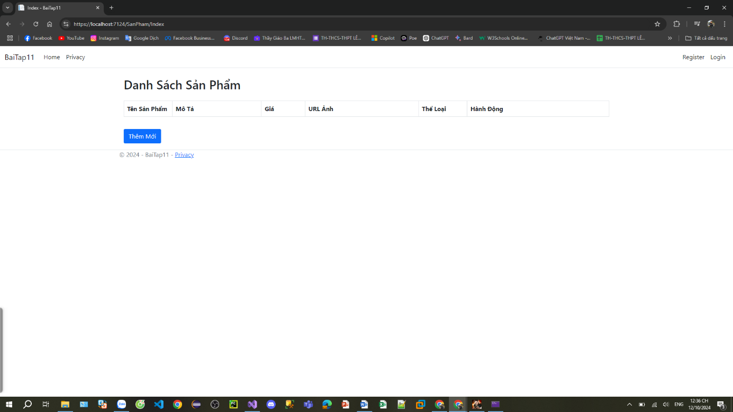Bài tập 11

using BaiTap11.Data;

using BaiTap11.Models;

using Microsoft.AspNetCore.Mvc;

using Microsoft.AspNetCore.Mvc.Rendering;

using Microsoft.CodeAnalysis.CSharp.Syntax;

using Microsoft.EntityFrameworkCore;

using System.Data.Common;

namespace BaiTap11.Controllers

{

public class SanPhamController : Controller

{

private readonly ApplicationDbContext _db;

public SanPhamController(ApplicationDbContext db)

{

_db = db;

}

public IActionResult Index()

{

IEnumerable<SanPham> sanpham = _db.SanPham.Include("TheLoai").ToList();

return View(sanpham);

}

[HttpGet]

public IActionResult Upsert(int id)

{

SanPham sanpham = new SanPham();

IEnumerable<SelectListItem> dstheloai = _db.TheLoai

.Select(sanpham => new SelectListItem

{

Text = sanpham.Name,

Value = sanpham.Id.ToString()

});

ViewBag.DSTheloai = dstheloai;

if (id == 0)

{

return View(sanpham);

}

else

{

sanpham = _db.SanPham.FirstOrDefault(sanpham => sanpham.Id == id);

return View(sanpham);

}

}

[HttpPost]

public IActionResult Upsert(SanPham sanpham)

{

if (ModelState.IsValid)

{

if (sanpham.Id == 0)

{

_db.SanPham.Add(sanpham);

}

else

{

_db.SanPham.Update(sanpham);

}

_db.SaveChanges();

return RedirectToAction("Index");

}

return View();

}

public IActionResult Delete(int id)

{

var sanpham = _db.SanPham.FirstOrDefault(sanpham => sanpham.Id == id);

if (sanpham == null)

{

return NotFound();

}

else

{

_db.SanPham.Remove(sanpham);

_db.SaveChanges();

}

return RedirectToAction("Index");

}

}

}

Index

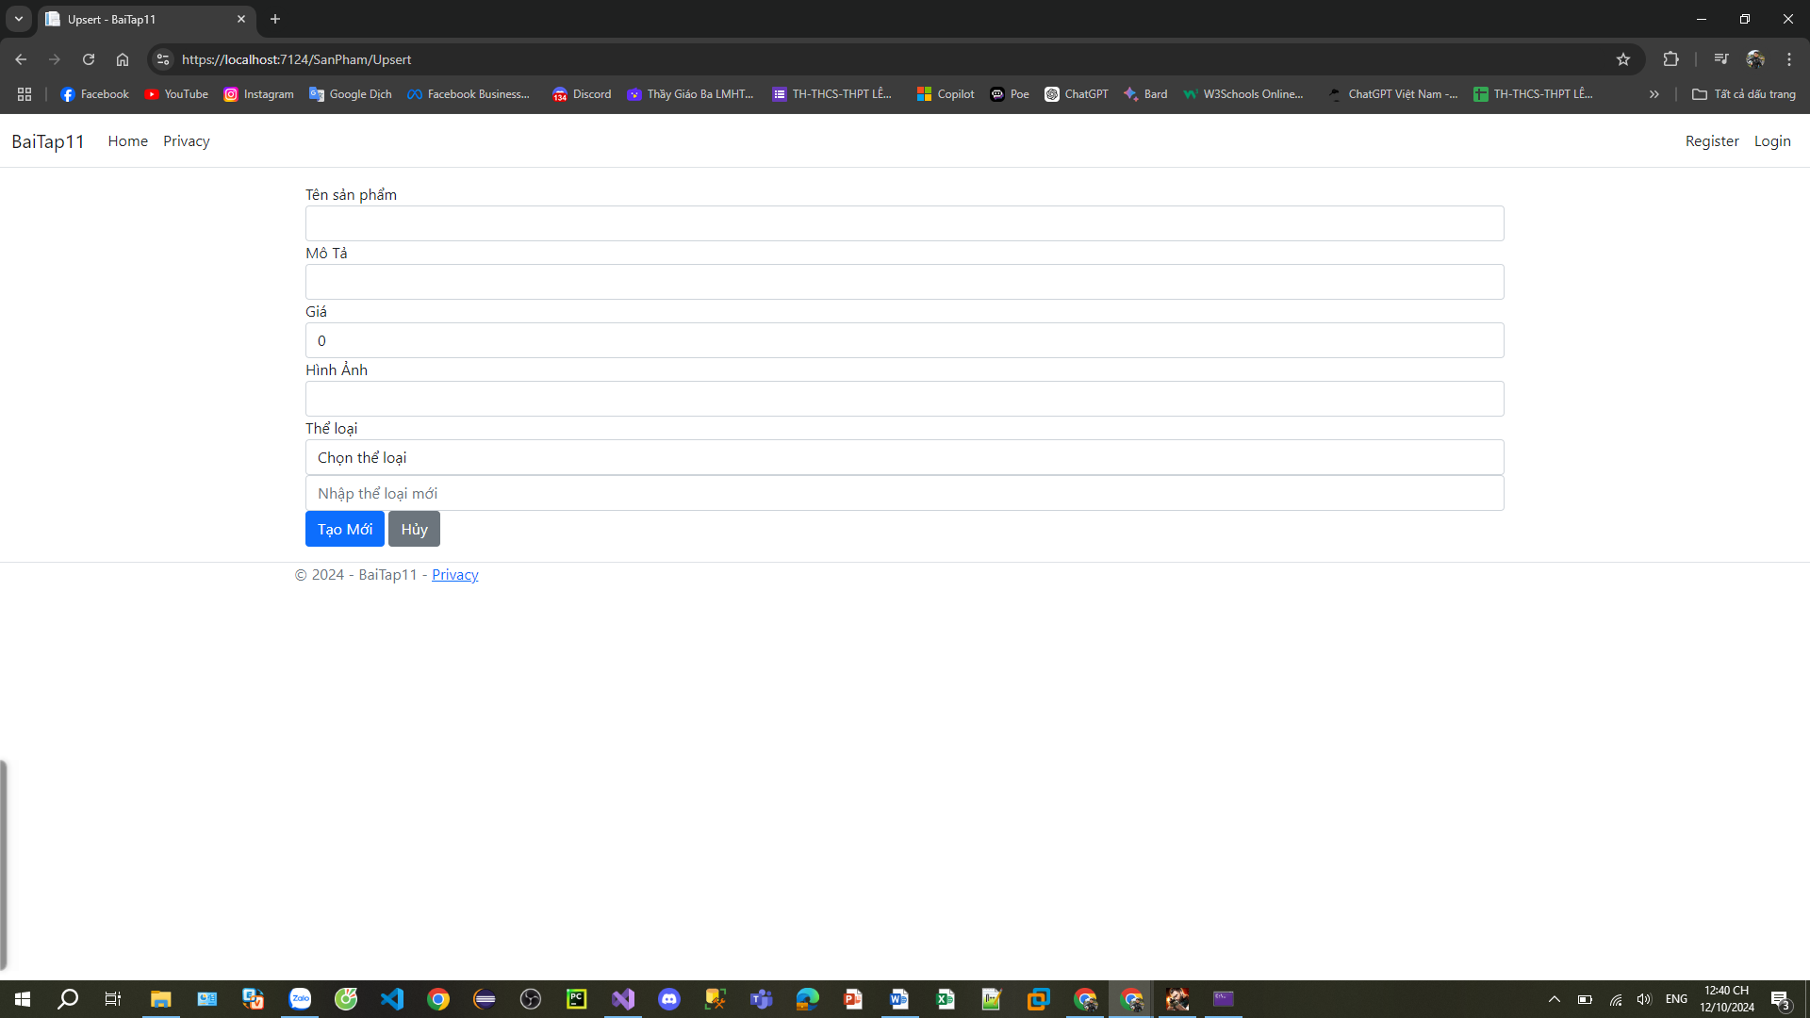

@{

ViewData["Title"] = "Index";

}

@model IEnumerable<SanPham>

<div class="container mt-4">

<h2 class="mb-4">Danh Sách Sản Phẩm</h2>

<div class="table-responsive">

<table class="table table-striped table-bordered">

<thead class="thead-light">

<tr>

<th style="width: 10%;">Tên Sản Phẩm</th>

<th>Mô Tả</th>

<th style="width: 9%;">Giá</th>

<th>URL Ảnh</th>

<th style="width: 10%;">Thể Loại</th>

<th>Hành Động</th>

</tr>

</thead>

<tbody>

@foreach (var item in Model)

{

<tr>

<td>@item.Name</td>

<td>@item.Description</td>

<td>@item.Price.ToString("#,0.000") VNĐ</td>

<td>

<a href="@item.ImageUrl" target="_blank" class="text-decoration-none">@item.ImageUrl</a>

</td>

<td>@item.TheLoai?.Name</td>

<td class="text-nowrap">

<**a** **asp-action**="Upsert" **asp-route-id**="@item.Id" class="btn btn-warning btn-sm me-1">Edit</**a**>

<**a** **asp-action**="Details" **asp-route-id**="@item.Id" class="btn btn-info btn-sm me-1">Detail</**a**>

<a onclick="xoa(@item.Id, $(this))" class="btn btn-danger btn-sm">Delete</a>

</td>

</tr>

}

</tbody>

</table>

</div>

<**a** **asp-controller**="SanPham" **asp-action**="Upsert" class="btn btn-primary mt-3">Thêm Mới</**a**>

</div>

<script>

const xoa = (id, row) => {

$.ajax({

url: `/SanPham/Delete/${id}`,

type: "POST",

})

.done(function (data){

row.closest("tr").remove();

})

}

</script>